Hayes School PTA
Annual General Meeting – 14th November 2017
The Library, Hayes School
Attendees: Julia Bunnage, Fiona Caschetto, Richard Cracknell, Charlotte Denton, Connie Entwistle, Paul Foster, Caroline Green, Katie Herbert, Terri Rose, Paul Swift, Steve Whittle
1. Apologies for absence: Marian McGuigan
2. Minutes of last AGM: the minutes were agreed.
3. Chair’s Report:
If I may I would like to go back a bit further than the last year as there are a collaboration of events and people who have got us to where we are. Julia Bunnage, Nina Simmons and I all left a PTA meeting 6 years ago as total strangers but together we became the new PTA.
Our fridges were the best purchase we ever made and we meant business whilst having lots of fun doing it!! Terri Rose our treasurer joined us 4 years ago, following Paul Gadsdon and in 2015 Julia stepped down and Fiona Caschetto who was already a very active member stepped in to her role. Nina stepped down in 2016. Without all of them we wouldn’t have achieved what we have.
I will leave Terri to talk detailed figures but this year our gross income is £32,781 with an additional minimum £700 due in from theatre ticket offers!! Since 2011 our gross income is just over £113k.
2016/17 has been another very successful year. We organised a winter ball to celebrate the 60th anniversary of Hayes School. To keep costs down and profits at the max we decided to ask the 6th formers to staff the event, giving us parents an opportunity to also enjoy the ball. They were a real credit to the school. As a surprise to everyone attending we worked with some of the students who had been in the wonderful production of Les Mis earlier that year. The students provided the audience with a wonderful flash mob medley of Les Mis which had over 1200 views on Nina’s facebook page. Yes the sixth form helpers threw a few plates in the bin towards the end of the event, but I would have too after serving over 120 people 3 courses and the trauma of seeing parents dancing!
Nearly 5 years ago, we decided we wanted to hold an outdoor music festival and we asked Mr Gunning to help us. 7 months later, Hazefest took place on Gadsden lawn. Bringing bands of students, teachers and ex students together. And 4 years on it is becoming a concrete event on the school calendar with Mr Tucker part of our gang as sound manager. Hazefest isn’t the biggest income generator but it really is an event where talent is plentiful and Hayes comes together. When the rain clouds disappear and the sun shines I don’t think you could ask for a better event.
Mr Gunning and Miss Werry have been great supporters of the PTA allowing us to run cash bars at their events.
We have built such great relationships with heads of departments, staff, teachers, governors and I would like to extend our gratitude in particular to Richard Cracknell, Paul Foster and Steve Whittle. Steve Madder and his team in site, June and Monique in the school office and June Riley. Parents, Verity Bolton who independently runs the Nearly New Shop with all donations going to the PTA and Paul Swift for our website and finally to Andrew Naish, Chair of the Governors and his wife Alison who support our events!!
After years of badgering poor Steve Whittle for projects to raise funds for, we had a presentation from the school council. Who better to tell us what the students needed. We successfully raised funds to improve the canteen so the queues were far quicker at breaks and lunchtime, a canopy which was built in the half term providing covered seating. Other donations we have made include a kiln for the art department, equipment for the science department, instruments for music and the sound system in the main hall. Then there is the fitness centre which we will discuss in a minute. Fiona and I have also recently attended a school council meeting and have some projects we would like to fulfil in this meeting.
The PTA wouldn’t be possible without the support of our members. 580 are now on our mailing list. We are so grateful to everyone who has helped at events or attended them, purchased a Hayes Ball and come to our meetings.
We strongly believed that every donation made benefit as many students as possible. Our students need the PTA to continue to raise funds towards projects. So after 6 years I would like to say I have thoroughly enjoyed my time on the PTA and made life long friends through it.
I would like to wish the new committee members all the very best.
Charlotte Denton
Chair
4. Treasurer’s Report:
Treasurer Report for AGM
Over £32.7k received in income –
· main events include school refreshments – overall profit £3.2k
· Hazefest - £4.5k income and profit of £2242.75 This was much better than previous years even though we didn’t sell alcohol at this event
· Fireworks £4.9k – profit £2.7k
· Winter Ball income £6.3k profit £1.8k plus £1k for the 60th Raffle. It was decided at a meeting this should only be bi-annually but was a very good income earner.
· Thanks to Verity who has organised the 2nd hand uniform sales we have raised £1701 this year – which is pure profit
· Misc – relates to items such as mytutor web, prom donation, match funding for the football tour where we used our charity status for someone to donate
PTA Donations have increased substantially this year from £1500 to £3,287.94 – this has come from new year 7 parents as well as via parentpay for all students
Match funding remained steady at £1,510 and we thank those who requested this from their employer.
Outgoings
Besides the expenses incurred for running events the rest was the Hayes Ball prize money and school requests
The school requests made up £5,955 however we have handed the school a cheque for £13.8k to cover the outdoor seating area which was agreed at the last AGM.
I’d like to thank Fiona and Charlotte for all their help on the PTA and the time and effort they have put into running the events over the last few years including ensuring I sent invoices out as necessary!
5. Donation of funds to projects:
Fitness Suite – PTA voted in favour of donating £10K towards this project despite reservations about its use for all students in the school and whether our funds would just sit in the bank or actually make a difference to the fundraising effort as the target has still not been reached. SW confirmed that the intention is for all students to benefit from the facilities and that the school hope to have the suite ready for September 2018.
The other items voted on and agreed by the PTA were from the Student Council Wish List:
Outdoor seating (benches around the grounds)
Indoor seating (sofas and benches in corridor areas where students currently sit on the floor at break / lunch times)
Heaters / Fans for all classrooms in D Block
Water supply in M block and on the top floor of the Science Block (latter request added by RC at the meeting)
The PTA have estimated approximate budgets for these items with the school to confirm final costs. Total approx. £20K.
Students had also asked for keyboards to be replaced however SW confirmed that the school would cover those.
6. Elect Committee members:

Katie Herbert was proposed for Chair by Charlotte Denton and seconded by Fiona Caschetto.
Terri Rose agreed to stay on as Treasurer.

7. Vice Principal’s report:
Senior Vice Principal’s Report to PTA AGM (November 2017)
Thank you for all your work over the last year as a committee and as officers to support the school.
Particular thanks to Fiona and Charlotte who, after a considerable term of service to the PTA are stepping down.
The PTA has generated a gross income of £32,781 this year and since 2011 a gross income over £113,000 which while many have contributed is in no small way a result of their hard work and leadership.
On behalf of the School I want to take this opportunity to publically thank Charlotte and Fiona for their leadership, drive and determination in fundraising that has had an immense impact the students of Hayes School. The desire to make sure that ‘every donation impacts upon as many students as possible’ has been a real driver in their leadership and one they have lived up to. Recently, not only has the PTA raised money but it has also devised events that enhance Hayes School and community beyond measure. Events such as Hazefest and the Winter Ball are certain to remain the highlights of the calendar and among many of the fitting testaments to their work on the PTA.
I also want to thank all the parents who attend PTA meetings, help and support at school events and donate funds in support of the school, the value it adds to the school is immense and hugely appreciated.

New Covered Seating funded by the PTA
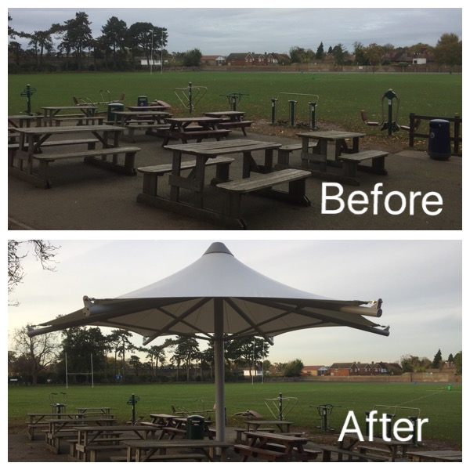

This has been put up over the half term break, looks really good and in this November is already very much valued and appreciated by the students.
Events/enrichment activities
- Photos Day
- Musicfest
- Rugby Tour to S Africa
- Languages Week, Big Draw, Remembrance
- School show rehearsals
- Somme Trip this week
- Y7 Concert next week
- E-Safety

Community
- Open Day and tours of school
- Hosted a visit from teachers from Norway
- Residents meetings
- Poppy selling at Hayes Station
- Relaunch of School Council
- Further developing our alumni network
Parents
- Parent Information Evenings
- Tutor Evening – Y7 and Y10
- E-Safety Evening for Parents
School Improvement
- Our exam results this summer were our best ever at A level and well above national average for progress at GSCE (in a year that is difficult to compare to previous ones)
- We are having a Challenge Partners peer review of school on the 5th and 6th December and preparations are well under way.
- New part time Vice Principal Ian Storey has started this half-term and is already making a positive impact on the students and staff.
- Continue to drive ABC…
  - Achievement
  - Behaviour
  - Consistency

8. AOB
CD and FC to meet with Katie to handover and will continue to support as required. CD and FC will still run Hazefest if required and FC will continue to run Hayes Balls for the rest of 2017 and the First Aid Courses.
It was felt PTA needs at least one other committee member to support Katie and Terri. School to make request in newsletter.

FC 1/12/17

